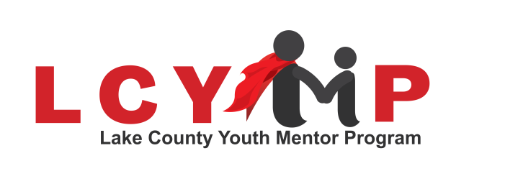

**Lake County Youth Mentor Program**

**"Be A Hero"**

Dear Parents/Guardians,

Your student is invited to participate in the Lake County Youth Mentor Program’s **5th and 6th grade** Boy Group Program. The program will be held at the Memorial Hall on **Fridays starting October 4th.** Lake County Youth Mentor staff and adult mentors will interact with the students in group activities that teach the students new skills and encourage creativity. The mentors will focus on fun, hands-on, and interesting ways to develop such skills as problem solving, setting boundaries, time management, communication, positive peer relationships, and respect for self and others.

Each month teachers will distribute a flyer describing the activities for the monthly gathering. This will give the students the opportunity to determine if they want to participate that month. If your student attends an activity he/she must come prepared to fully participate in the activities offered or he/she will be asked to leave.

Our program is committed to the safety and well-being of your student. Because of this, all mentors have undergone criminal background and personal reference checks through our program. We would welcome your participation in the program but would have to ask you to go through the process of becoming a mentor. Again, this is for the safety and well-being of all the students who attend our program activities.

Please fill out the enclosed permission form and have your student return it to you students teacher ASAP.

If you have any questions, please do not hesitate to contact us at 541-947-4880. We look forward to having your student participate in the program.

Sincerely,

Donna Palmer

Donna Palmer

Youth Mentor Program Director